**[Basic information]**

The cases we listed in the paper are

osa-miR818b::LOC_Os06g17950 &

osa-miR818b::LOC_Os12g16290

(Why are these two cases specially mentioned? Because they have the least number of SNPs 4 SNPs, and were found to recover the complementarity)

With the alignment illustrations below (b, d):

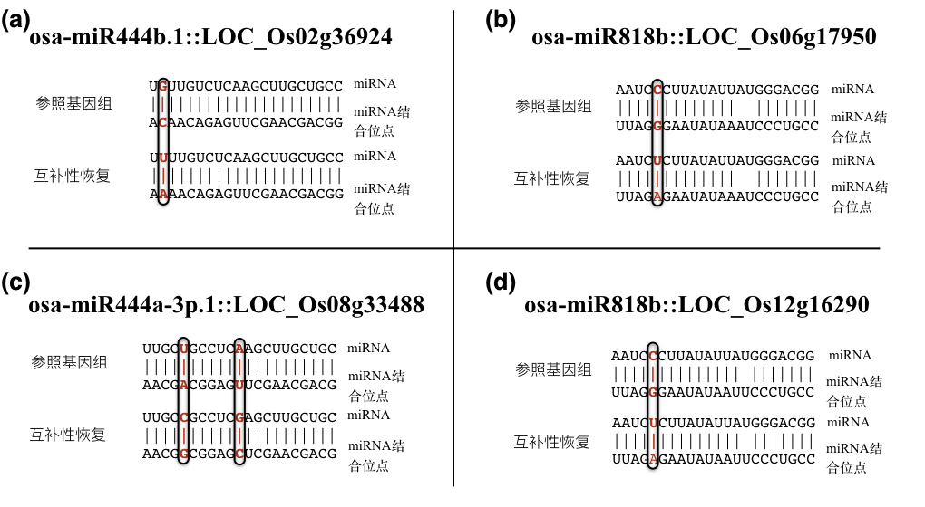

Putative functions of these two genes are:

**LOC_Os06g17950**: **NBS-LRR** disease resistance protein

Reported functions: **pathogen sensing and host defense**

LOC_Os12g16290: isoflavone reductase 异黄酮还原酶

Reported functions:

1. For a similar gene, OsIRL, isoflavone reductase-like gene, induced by treatment with a fungal elicitor and jasmonic acid as well as by inoculation with rice blast fungus稻瘟病菌
2. Overexpression of rice isoflavone reductase-like gene (OsIRL) confers tolerance to reactive oxygen species (活性氧)

**[The exciting part]**

A recent paper

*Y. Zhang, R. Xia, H. Kuang, B.C. Meyers, The diversification of plant NBS-LRR defense genes directs the evolution of MicroRNAs that target them. Mol Biol Evol, 33 (2016), pp. 2692–2705*

Reported the NBS_LRR genes were targeted by miRNAs in various plant species, and

*We observed that duplicated NBS-LRRs from different gene families periodically gave birth to new miRNAs. Most of these newly emerged miRNAs target the same conserved, encoded protein motif of NBS-LRRs, consistent with a model of convergent evolution for these miRNAs. By assessing the interactions between miRNAs and NBS-LRRs, we found nucleotide diversity in the wobble position of the codons in the target site drives the diversification of miRNAs. Taken together, we propose a co-evolutionary model of plant NBS-LRRs and miRNAs hypothesizing how plants balance the benefits and costs of NBS-LRR defense genes.*

Logic:

*Our explanation of the complementarity recovery phenomenon was that during the evolution of rice miRNA and its target, for some rice cultivars, constraint of complementarity became looser and allowed the mismatch at position 5. So, the single mutation could happen at this position, but afterward, the constraint arose again and forced the miRNA:target interaction pair to become pairing again at this position.*

This guess may be possible, and gain support from the paper above.

* Both genes are responsible for plant stress response, so their regulation relationship shall accustom quickly to the environment, and in fact repond to the changes of environment; And it would be properly suggested that, the miRNA regulation is part of plant’s response to environmental stresses;
* For the evolution model come up at the paper, they have found that some precursors of miRNAs, targeting the NBS-LRR genes, have extended similarity (beyond the mature miRNA sequence) to NBS genes. (with BLAST cutoff evalue < 10-5 )
* Many miRNAs that targets NBS-LRR genes are lineage-specific miRNAs, and miR818 are relatively new and rice-specific, (although not mentioned in the paper as the targeting miRNA in rice)

I have BLASTed the osa-miR818b precursor sequence to the rice genome, and found that

**[BLAST result part]**

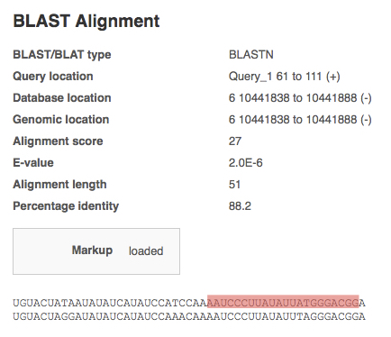

* The upper sequence was part of precursor of osa-miR818b, while the lower sequence was part of LOC_Os06g17950 (NBS-LRR). The sequence marked in red is the mature miRNA part.
* The sequence of the gene LOC_Os06g17950 contains the predicted miRNA binding site, just the opposite strand of the red-marked mature miRNA sequence.
* The evalue 2E-6 < 1E-5, and the alignment length 51 was almost half the length of pre-miR818b (113)

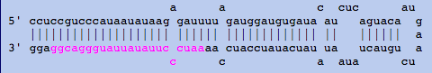

The structure of pre-miR818b;

So this somehow supports the co-evolution model of plant NBS-LRRs.

**[What’s more]**

There are two other miRNAs that have complementarity recovery phenomenon **at position 5 with the above 2 genes**, osa-miR818a and osa-miR818b

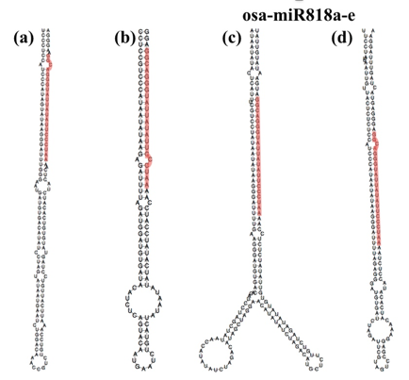

This is the 2nd structure prediced of the pre-miRNAs of osa-miR818a, b, d;

And they have similar 2nd structure.

And the BLAST of osa-miR818b with another gene, LOC_Os12g16290, have the following alignment result:

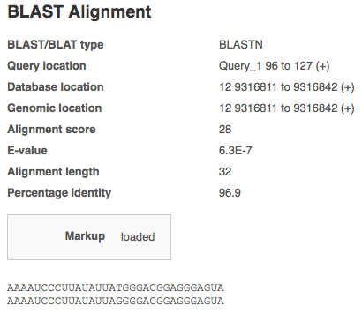

and with evalue 6.3E-7 < 1E-5, and alignment length is 32,